Lecture 01 – Data Communication PDF
📡 1. Define Data Communication
Data communication is the exchange of data between two devices via a transmission medium like wire or cable.
⚙️ 2. Characteristics of Data Communication
- Delivery: Data must reach the correct destination.
- Accuracy: Data must be delivered without errors.
- Timeliness: Data must arrive on time (especially for audio/video).
- Jitter: Jitter refers to the variation in the packet arrival time. It is the uneven delay in the delivery of audio or video packets.
🧩 3. Components of Data Communication
- Message – The data (text, audio, video, etc.)
- Sender – The sender is the device that sends the data message
- Receiver – The receiver is the device that receives the message.
- Transmission Medium – The transmission medium is the physical path by which a message travels from sender to receiver. (e.g., cable, radio)
- Protocol – A protocol is a set of rules that govern data communications.
🔁 4. Classification by Data Flow
- Simplex – In simplex mode, the communication is unidirectional, as on a one-way street. Only one of the two devices on a link can transmit; the other can only receive (e.g., keyboard to monitor)
- Half-Duplex – In half-duplex mode, each station can both transmit and receive, but not at the same time. When one device is sending, the other can only receive, and vice versa. (e.g., walkie-talkie)
- Full-Duplex – In full-duplex mode (also called duplex), both stations can transmit and receive simultaneously . The full-duplex mode is like a two-way street with traffic flowing in both directions at the same time. (e.g. teliphone)

🌐 5. Define Computer Network
A network is a set of devices (often referred to as nodes) connected by communication links.
📊 6. Criteria of a Computer Network
- Performance – Can be measured in many ways, including transit time and response time.
- Transit time is the amount of time required for a message to travel from one device to another device.
- Response time is the elapsed time between an inquiry and response.
- Reliability – In addition to accuracy of delivery, network reliability is measured by the frequency of failure, the time it takes a link to recover from a failure and the network's robustness in a calamity. [Failure rate, recovery time]
- Security – Protection from unauthorized access and damage
🔗 7. Types of Connections
A network is two or more devices connected through links. A link is a communications pathway that transfers data from one device to another.
For visualization purposes, it is simplest to imagine any link as a line drawn between two points. For communication to occur, two devices must be connected in some way to the same link at the same time. There are two possible types of connections:
▪ Point-to-point and ▪ Multipoint.
A point-to-point line configuration provides a dedicated link between two devices. The entire capacity of the channel is reserved for transmission between those two devices. When you change television channels by infrared remote control, you are establishing a point-to-point connection between the remote control and the television's control system.
Multipoint (also called multidrop) connection is one in which more than two specific devices share a single link. In a multipoint environment, the capacity of the channel is shared, either spatially or temporally.

🕸️ 8. Topologies with Figures, Advantages & Disadvantages
- Mesh – In a mesh topology, every device has a dedicated point-to-point link to every other device. The term dedicated means that the link carries traffic only between the two devices it connects. [Every device connects to every other]
  - ✅ Robust, private, fault isolation. A mesh topology is robust. If one link becomes unusable, it does not incapacitate the entire system.
  - ❌ Expensive, complex installation
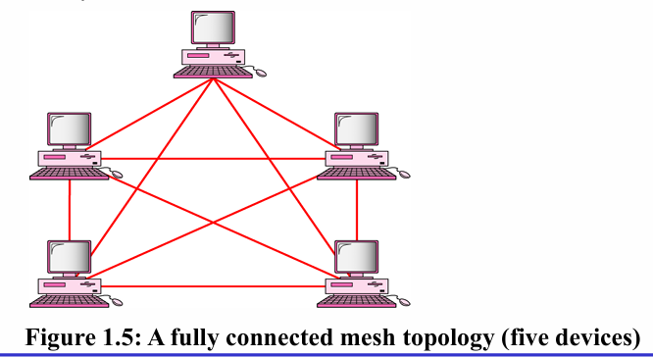
- Star – In a star topology, each device has a dedicated point-to-point link only to a central controller, usually called a hub (or switch) [Devices connect to a central hub]
  - ✅ Easy to manage, fault isolation. The star topology is robust. If one link fails, only that link is affected.
  - ❌ Hub failure affects entire network. Although a star requires far less cable than a mesh, The star topology is used in local-area networks (LANs).
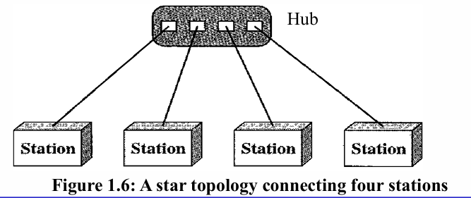
- Bus – One long cable acts as a backbone to link all the devices in a network. Nodes are connected to the bus cable by drop lines and taps. A drop line is a connection running between the device and the main cable. [Single backbone cable]
  - ✅ Simple, less cabling
  - ❌ Fault affects all devices, Difficult reconfiguration and fault isolation, A fault or break in the bus cable stops all transmission
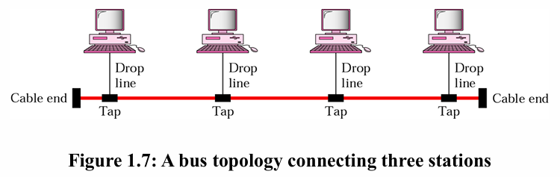
- Ring – In a ring topology, each device has a dedicated point-to-point connection with only the two devices on either side of it. A signal is passed along the ring in one direction, from device to device, until it reaches its destination. Each device in the ring incorporates a repeater. When a device receives a signal intended for another device, its repeater regenerates the bits and passes them along. [Devices form a closed loop]
  - ✅ Easy to add/remove, fault detection
  - ❌ One break disables network
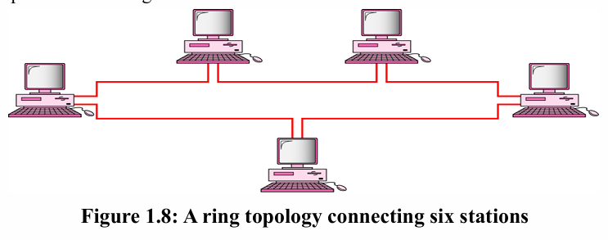
- Hybrid – Combination of topologies.
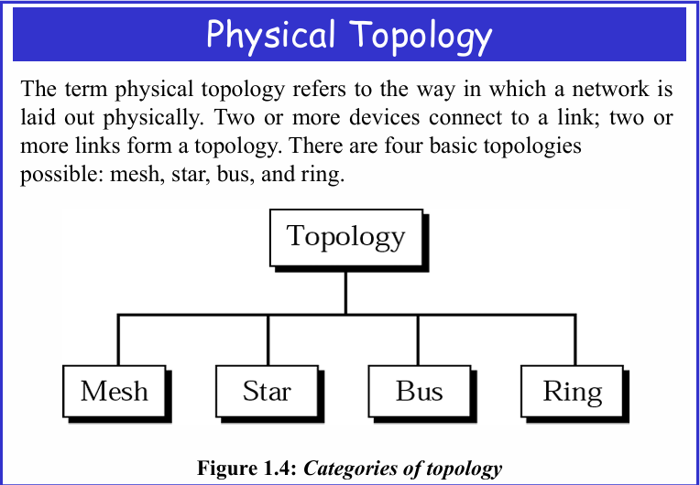
🏙️ 9. Demonstrate LAN, MAN, WAN
- LAN – A local area network (LAN) is usually privately owned and links the devices in a single office, building, or campus.
- MAN – A metropolitan area network (MAN) is a network with a size between a LAN and a WAN. It normally covers the area inside a town or a city.
- WAN – A wide area network (WAN) provides long-distance transmission of data, image, audio and video information over large geographic areas that may comprise a country, a continent, or even the whole world.
🔍 10. Differences Among LAN, MAN, WAN
Feature | LAN | MAN | WAN
Range | 1–10 km | ~100 km | Beyond 100 km
Media Used | Guided | Guided & Unguided | Unguided
Speed | High (100 kbps–100 Mbps) | Moderate | Lower than LAN
Cost | Cheap | Costly | Expensive
Equipment | NIC, switch, hub | Modem, router | Microwave, radio, laser
Protocols | ARCNET, Token Ring | Frame Relay, ATM | ATM, FDDI, SMDS

📜 11. Protocol and Key Elements
- Protocol – A protocol is a set of rules that govern data communications. A protocol defines what is communicated, how it is communicated and when it is communicated.
- Key Elements:
  - 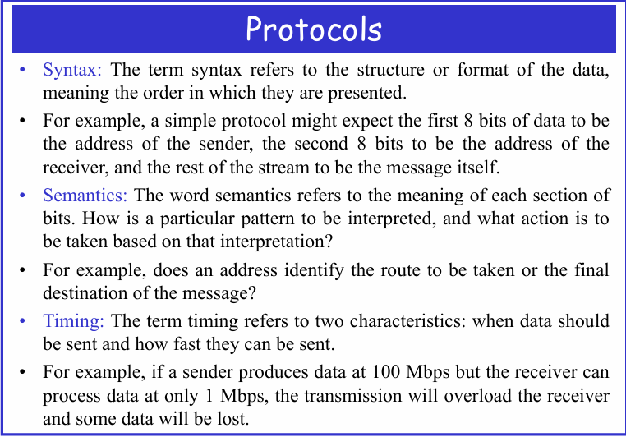 DONE
Chapter-2 Network Models
📡1. Define Network
A network is a combination of hardware and software that sends data from one location to another.2
⚙️ 2. Layered Tasks Concept
- Communication is divided into layers for simplicity.
- Example: Sending a letter involves:
  - Higher Layer: Writing and addressing the letter
  - Middle Layer: Carrier picks and delivers to post office
  - Lower Layer: Sorting and transporting to destination
🧩 3. OSI Model Overview
OSI Model
The International Standards Organization (ISO), established in 1947, is a global body responsible for creating worldwide technical standards. One of its major standards for networking is the Open Systems Interconnection (OSI) model, which was introduced in the late 1970s.
The OSI model is not a protocol; rather, it is a conceptual framework used to understand, design, and standardize network architectures. It defines how communication should occur between different computer systems, even if their hardware and software architectures are different.
An open system refers to a collection of protocols that enables interoperability, meaning any two systems can communicate regardless of differences in structure.
The main goal of the OSI model is to facilitate communication between heterogeneous systems without requiring changes to their internal design. It ensures that the network is flexible, robust, and interoperable.
The OSI model contains seven layers, where each layer handles a specific part of the data communication process. Together, these layers describe how information moves across a network from sender to receiver.

🧱 4. 7 Layers of OSI Model
Layer No. | Name | Function Summary
1 | Physical | It deals with the mechanical and electrical specifications of the interface and transmission medium. It also defines the procedures and functions that physical devices and interfaces have to perform for transmission to Occur.
2 | Data Link | Data link layer performs the most reliable node to node delivery of data. It forms frames from the packets that are received from network layer and gives it to physical layer. It also synchronizes the information which is to be transmitted over the data.
3 | Network | The network layer is responsible for the source-to-destination delivery of a packet, possibly across multiple networks (links). Where as the data link layer oversees the delivery of the packet between two systems on the same network (links), the network layer ensures that each packet gets from its point of origin to its final destination
4 | Transport | The transport layer is responsible for process-to-process delivery of the entire message. A process is an application program running on a host. Whereas the network layer oversees source-to-destination delivery of individual packets, it does not recognize any relationship between those packets.
5 | Session | The session layer provides the mechanism for opening, closing and managing a session between end-user application processes. Communication sessions consist of requests and responses that occur between applications.
6 | Presentation | The presentation layer is concerned with the syntax and semantics of the information exchanged between two systems.
7 | Application | The application layer enables the user, whether human or software, to access the network. It provides user interfaces and support for services such as electronic mail, remote file access and transfer, shared database management, and other types of distributed information services.

🔌 5. Physical Layer Responsibilities
The Physical Layer is the foundation of the OSI model. It ensures raw bits are transmitted over a physical medium. Key responsibilities:
- Physical characteristics of interfaces and medium: Defines connectors, cables, fiber optics, and wireless standards.
- Bit representation: Converts binary data (0s and 1s) into electrical, optical, or radio signals.
- Data rate: Specifies how many bits per second can be transmitted (bit duration).
- Synchronization of bits: Ensures sender and receiver clocks are aligned.
- Line configuration: Supports point-to-point (direct link) or multipoint (shared link) connections.
- Physical topology: Defines how devices are arranged (mesh, star, ring, bus).
- Transmission mode: Controls direction of communication:
  - Simplex: One-way only
  - Half-duplex: Two-way but one at a time
  - Full-duplex: Two-way simultaneously
🔗 6. Data Link Layer Responsibilities
The Data Link Layer ensures reliable node-to-node delivery. Key responsibilities:
- Framing: Groups raw bits into structured units called frames.
- Physical addressing: Adds sender/receiver addresses (MAC addresses) in the frame header.
- Flow control: Prevents fast senders from overwhelming slow receivers.
- Error control: Detects and retransmits lost or corrupted frames (using checksums/trailers).
- Access control: Determines which device can use a shared medium at a given time (important in multipoint links).
🌐 7. Network Layer Responsibilities
The Network Layer manages source-to-destination delivery across multiple networks. Key responsibilities:
- Logical addressing: Uses IP addresses to uniquely identify devices across networks.
- Routing: Determines the best path for packets through routers/switches.
- Packet forwarding: Ensures packets reach the correct destination even across different networks.
📦 8. Transport Layer Responsibilities
The Transport Layer ensures complete, error-free delivery of messages between processes. Key responsibilities:
- Service-point addressing (Port addressing): Identifies which application/process should receive the data (e.g., HTTP → port 80).
- Segmentation and reassembly: Breaks large messages into smaller segments, numbers them, and reassembles at destination.
- Connection control:
  - Connection-oriented (TCP): Establishes a session before sending data.
  - Connectionless (UDP): Sends data without prior setup.
- Flow control: End-to-end regulation of data transfer speed.
- Error control: Ensures entire message arrives intact (retransmission if needed).
🧪 9. Session Layer Responsibilities
The Session Layer manages dialogs between applications. Key responsibilities:
- Dialog control: Allows communication in half-duplex or full-duplex mode.
- Synchronization: The session layer allows a process to add checkpoints or synchronization points, to a stream of data. If a crash occurs, only data after the last checkpoint needs to be resent.
- Session recovery: Can reopen or restore sessions after interruptions.
🎨 10. Presentation Layer Responsibilities
The Presentation Layer ensures data is in a usable format for the application. Key responsibilities:
- Translation: Converts data between different encoding formats (ASCII, EBCDIC, Unicode).
- Encryption/Decryption: Secures sensitive information during transmission.
- Compression: Reduces data size, especially for multimedia (text, audio, video).
👤 11. Application Layer Services
The Application Layer is closest to the user, enabling direct interaction with network services. Key services:
- Network virtual terminal: Software emulation of a physical terminal, allowing remote login.
- File transfer, access, and management (FTAM): Enables reading, writing, and managing files on remote systems.
- Mail services: Provides email forwarding, storage, and retrieval.
- Directory services
🔢 12. Protocols by Layer (Examples)
Layer | Protocols (Examples)
Physical | RS232, USB, DSL
Data Link | PPP, ARP, HDLC
Network | IP, ICMP, OSPF
Transport | TCP, UDP, SCTP
Session | RPC, NetBIOS, ZIP
Presentation | SSL, TLS, MPEG
Application | HTTP, FTP, SMTP
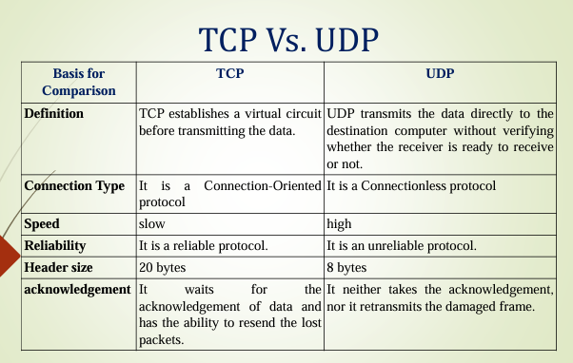
⚔️ 13. OSI vs TCP/IP Model
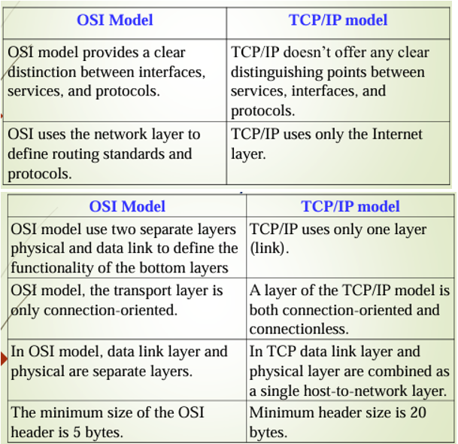
Lec 3
1. Define analog data, analog signal, digital data, and digital signal with examples.
- Analog Data: Data that varies continuously over time and can take any value within a range.
Example: Temperature readings, human voice.
- Analog Signal: A continuous-time signal that represents analog data.
Example: Voltage variation in a microphone representing sound.
- Digital Data: Data represented in discrete form, usually in binary (0s and 1s).
Example: Text files, computer data, binary numbers.
- Digital Signal: A signal that represents digital data as discrete voltage levels.
Example: Signals in a computer network, digital audio (CD music).

2. Differentiate Periodic and Aperiodic signals
Feature | Periodic Signal | Aperiodic Signal
Definition | Repeats itself at regular intervals | Does not repeat over time
Period | Has a definite period $T$ | No definite period
Examples | Sine wave, cosine wave | Random noise, speech signals

3. State Period, Frequency, Phase, Wavelength with figures
- Period (T): The time taken for one complete cycle of a periodic signal.
Unit: seconds (s)
- Frequency (f): Frequency is the rate of change with respect to time. Change in a short span of time means high frequency. Change over a long span of time means low frequency
Formula: $f=\frac{1}{T}$
Unit: Hertz (Hz)
- Phase (φ): Phase describes the position of the waveform relative to time zero. The fraction of a cycle at a given time relative to a reference point.
Unit: degrees (°) or radians
- Wavelength (λ): The physical distance covered by one cycle of the wave.
Formula: $λ=\frac{v}{f}$where $v$is the speed of the wave
4. Define Bandwidth with examples
- Bandwidth: The difference between the highest and lowest frequencies of a signal that a channel can transmit effectively.
Formula: $BW=f_{max}-f_{min}$
Example:
- Voice signal: 300 Hz to 3400 Hz → Bandwidth = 3100 Hz
- Wi-Fi 2.4 GHz channel: 2.4 GHz ± 11 MHz → Bandwidth = 22 MHz

5. Advantages of Digital Signals
- Less susceptible to noise and interference
- Easier to store and process
- Can be encrypted for secure communication
- Compatible with modern computer and digital systems
- Multiplexing and error detection/correction are easier

6. Describe Transmission Impairments
Transmission impairments are factors that distort the signal during transmission. Main types:
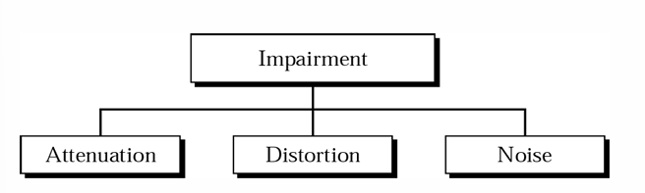
Transmission medium is not perfect => impairment in signal
- Attenuation: Loss of signal strength over distance. The decibel (dB) measures the relative strengths of two signals or a signal at two different points dB = 10 log10(P2/P1) Variables PI and P2 are the powers of a signal at points 1 and 2, respectively.
- Distortion: It means Change in signal shape during transmission. This is generally seen in composite signals with different frequencies. Every component arrive at different time which leads to delay distortion. Therefore, they have different phases at receiver end from what they had at senders end.
- Noise: The random or unwanted signal that mixes up with the original signal is called noise. There are several types of noise such as induced noise, crosstalk noise, thermal noise and impulse noise which may corrupt the signal

7. Classify Noise and Define Signal-to-Noise Ratio (SNR)
Noise is the unwanted or random signal that gets mixed with the original transmitted signal and distorts it.
There are several types of noise in communication systems, such as thermal noise, induced noise, crosstalk, and impulse noise, which can corrupt the signal.
Types of Noise
1. Thermal Noise
- Caused by the random motion of electrons inside a conductor/wire. This random movement produces an unwanted signal even when no data is sent. Present in all electronic devices and proportional to temperature.
2. Induced Noise
- Comes from external sources like motors, electrical machines, fluorescent lights, and household appliances. These devices act like sending antennas, and the transmission medium behaves like a receiving antenna, picking up unwanted signals.

3. Crosstalk
Occurs due to the effect of one wire on a nearby wire. One wire behaves as a sending antenna and the other as a receiving antenna. Causes interference between adjacent communication channels.
4. Impulse Noise
- A high-energy spike of very short duration. Caused by lightning, power line fluctuations, and electrical switching. One of the most disruptive types of noise.
Signal-to-Noise Ratio (SNR)
To determine the theoretical limit of data transmission, we must compare signal power to noise power.
Definition
$$\text{SNR}=\frac{\text{Average Signal Power}}{\text{Average Noise Power}}$$
A high SNR means the signal is less corrupted by noise; a low SNR means the signal is more corrupted by noise. Because SNR is the ratio of two powers, it is often described in decibel units, ${\text{SNR}}_{dB}$
SNR in Decibels (dB)
$${\text{SNR}}_{dB}=10{log⁡}_{10}(\text{SNR})$$
Decibel form is widely used because it simplifies calculations and covers a large range of values.

